Windows 10 Pro Default Image – Build & Capture

# Prerequisites

Follow the steps in the document [Windows 10 Imaging MDT Build Structure Setup](https://rbauction.sharepoint.com/it/kb/build/Windows%2010%20Imaging%20MDT%20Build%20Structure%20Setup.docx) to create a Virtual Machine that is used to deploy the base OS.

**Note:** The default image uses *administrator* profile as the basis of customization and capture.

## Snapshots

Snapshotting a VM before capturing an image is a very important step. It is important to take a snapshot of the VM after it has been shut down, and before you double-click the **Resume Task Sequence** icon on the desktop of the “*Administrator*” profile.

# OS Configuration

After the base OS is deployed, the desktop will resemble the following:

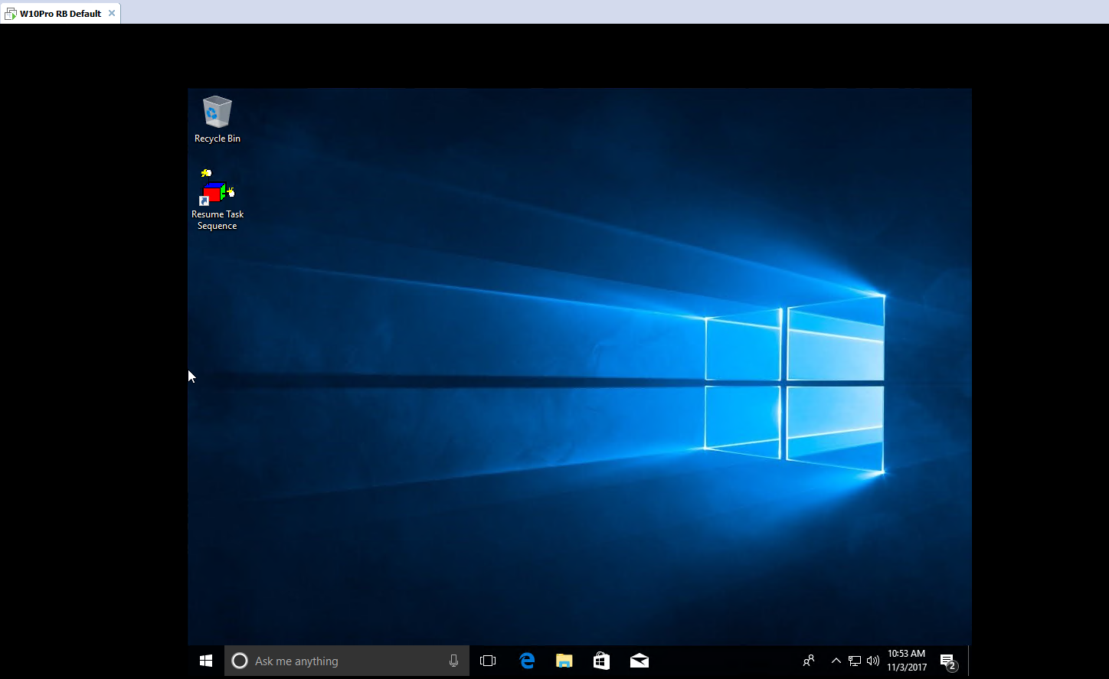

**Important:** DO NOT delete the **Resume Task Sequence** icon on the desktop.

## **Configure Local User Accounts**

The following table describes the local user accounts and how they should be configured:

1. Click **Star**t, type *compmgmt.msc*, and then press ENTER.  
   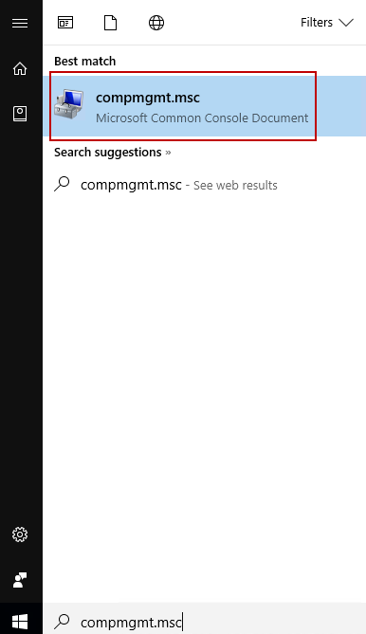
2. In **Computer Management**, expand **Local Users and Computers**. Right-click **Users** and then click **New User**.  
   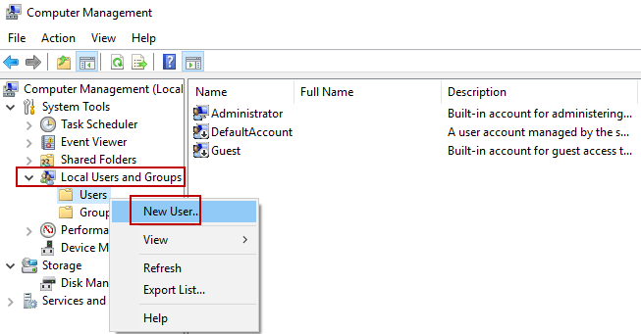
3. The following table describes the local user accounts and how they should be configured.

|  |  |  |  |
| --- | --- | --- | --- |
| Full Name | User ID | Groups | Purpose |
| Administrator | Administrator | Administrators | DISABLED AFTER image deployment. |
| rservice | rservice | Administrators | Used by support centre and operations |

Follow these steps to create the accounts and add them to the local groups:

1. Type the information from the table to the corresponding fields in the **New User** dialog box.
2. Type the password in the **Password** and **Confirm Password** boxes. **Note:** Contact the **IT Operations Analyst** team to obtain passwords.
3. Click to select the **User cannot change password** and **Password never expires** check boxes.
4. Click **Create**.  
   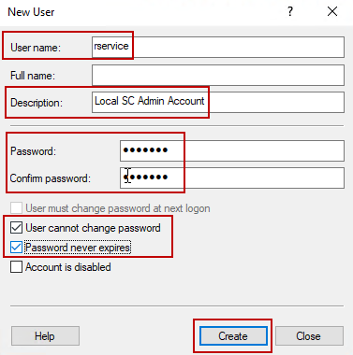
5. Double-click the account you just created, and then on the **Member of** tab, click **Add**.  
   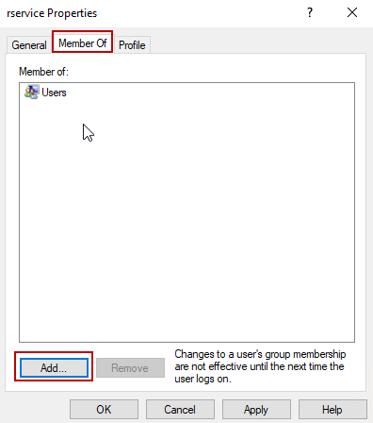
6. In **Select Groups**, in the **Enter the object names to select** area, type *Administrators* and then click **Check Names**. The group name is underlined if the correct value was entered.   
   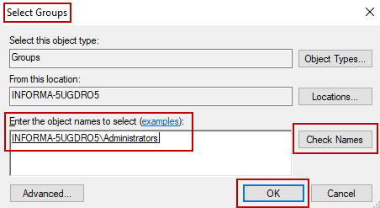
7. Click **OK**.
8. Double-click the account again, and then on the **Member of** tab, click **Users**, and then click **Remove**.
9. Repeat steps **a** - **i** to setup other accounts, as needed.
10. Click **Start**, type *Group Policy*, and then click **Edit group policy**.  
     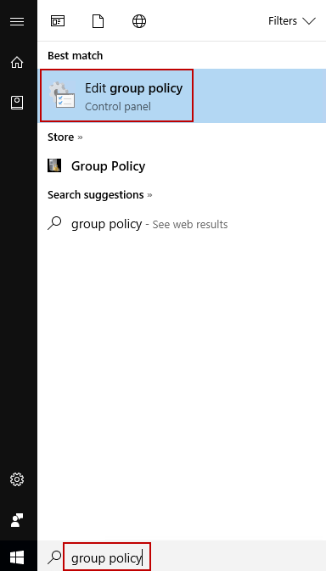
11. In **Local Group Policy Editor,** set the following group policies 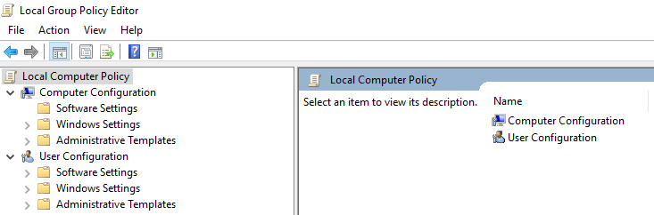
    1. Expand **Computer Configuration > Administrative Templates > Windows Components > Store**, and thenconfigure the following policies:
       1. “**Turn off the store application**” set “**Enabled**”.
       2. “**Turn off Automatic Download and Install of updates**” set “**Enable**d”.
    2. Expand **User Configuration > Administrative Templates > Windows Components > Internet Explorer > Advanced settings >Browsing**, and thenconfigure the following policies:
       1. “**Hide the button that opens Microsoft Edge**” set “**Enabled**”.
12. On the **hqppwmdt01** server, go to **C:\Setup\Scripts\**. Copy the script **Invoke-RemoveBuiltinApps.ps1** and paste it to the desktop of the computer that you are configuring.
13. Start PowerShell and browse to the administrator’s profile desktop folder.  
    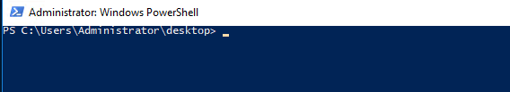
14. Type the command *Set-ExecutionPolicy UnRestricted* and then press ENTER.
15. When prompted to continue, type *A* to change the execution policy.  
    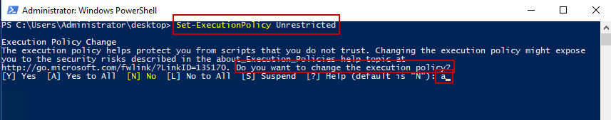
16. Type the name of the script file and then press ENTER.  
    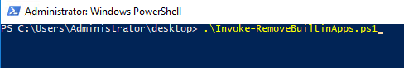  
    The following messages appear.   
    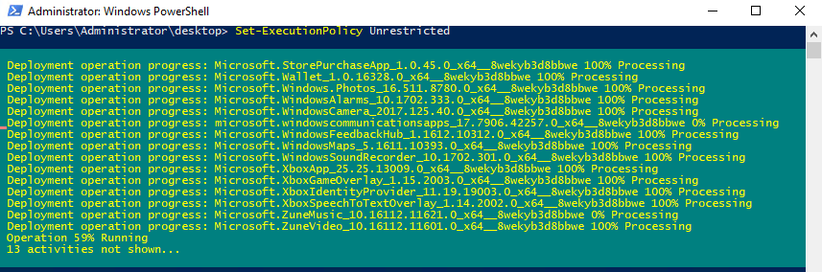  
    If the command completes without error, PowerShell will return to the prompt.   
    When successfully completed, delete the script from the desktop.  
    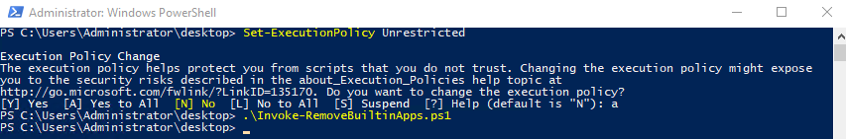
17. Click **Start** and unpin all the apps in the right-hand side of the menu. Also, unpin all shortcuts from taskbar except IE and File Explorer. The following screenshot shows what Start menu and taskbar should look like when you are finished.   
    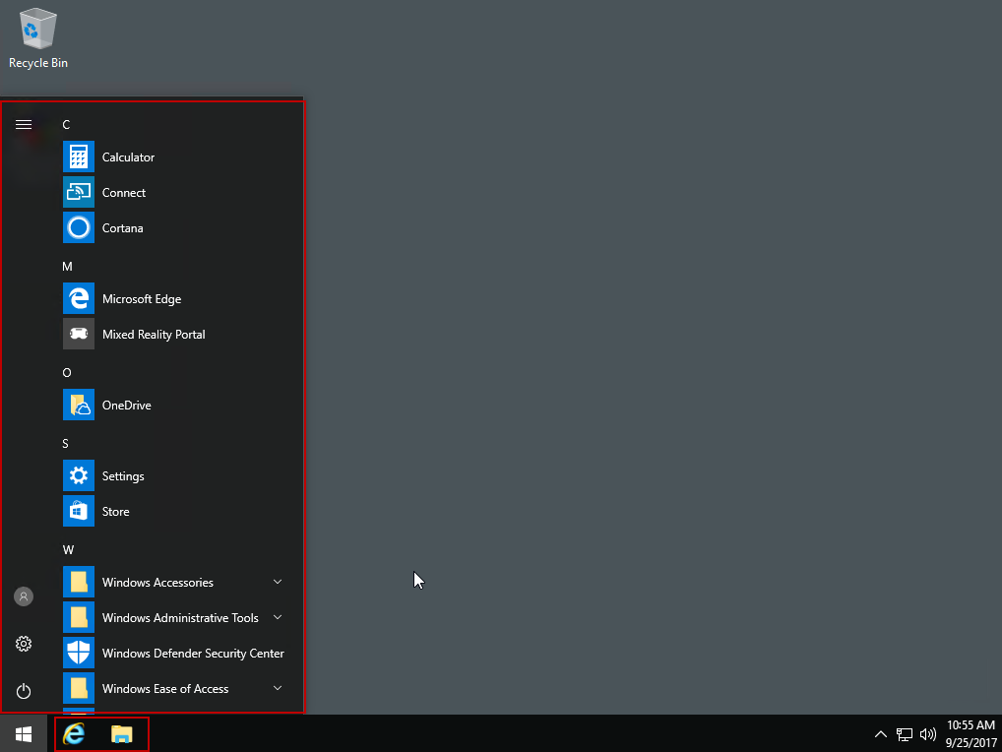
18. Start **File Explorer** and then on the **File** menu, select **Change folder and search options**. Set the following options:
    1. On the **General** tab, in the **Open File Explorer to list**, select **This PC**.
    2. On the **View** tab, click to select the **Show status bar** check box.
    3. Click **Apply to Folders**, and then click **Apply**.  
       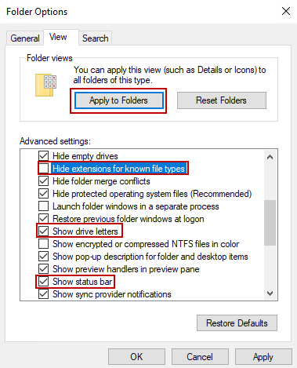
19. Click **Start**, type *user*, and then select **Change User Account Control Settings**.  
    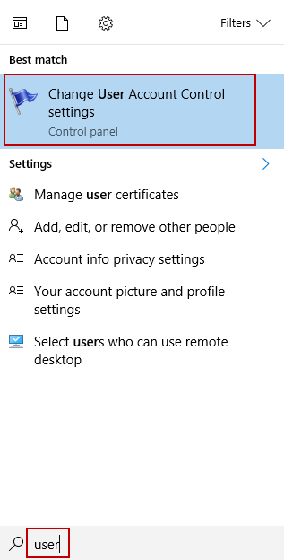
20. In **User Account Control Settings**, move the slider level down to **Never notify**, and then click **OK**.  
    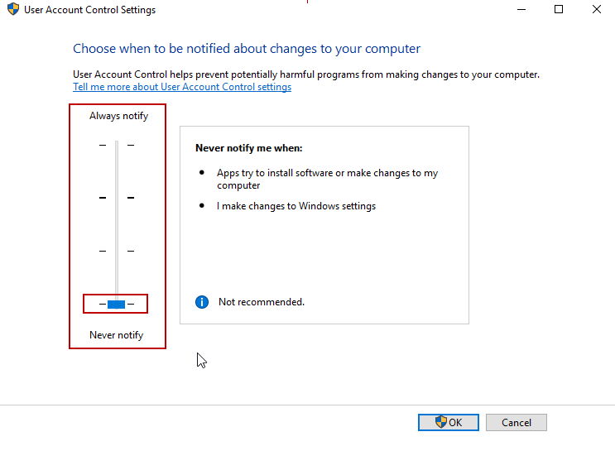
21. Click **Start**, and then click the gear icon to open **Settings**.  
    
22. In **Windows** **Settings**, click **Time & Language**.
23. On the **Date & time** page, toggle **On** the **Set time zone automatically** option.  
    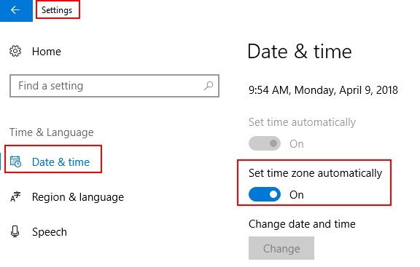
24. Click **Home** to return to the **Windows Settings** page, and then click **Devices**.
25. Select **Printers & scanners** and clear the **Let Windows manage on my default printer** check box and then close **Settings**.  
    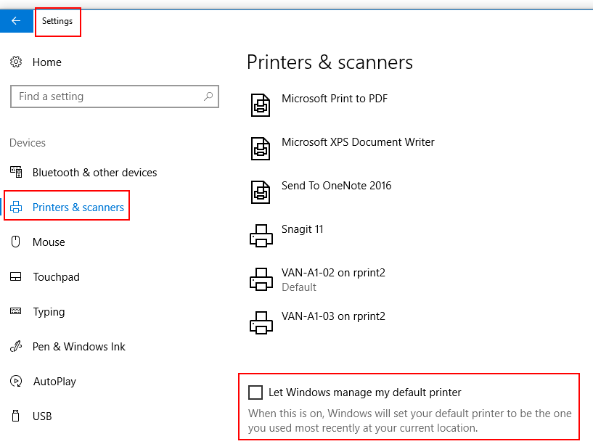

# Customize the Start Menu and set File Associations

The Start menu and File associations may need to be modified depending on what the image will be used for. There are no default customizations. For information about how to customize the Start Menu and set File Associations, go to the following *System Center Dudes* blog post:

<https://www.systemcenterdudes.com/sccm-windows-10-customization/>

# Install Software under the Administrator profile

The following software must be installed while you are signed on as the Administrator.

1. Install SAP Crystal Reports runtime engine from the following location:

file:///\\vanstore1\software\Applications\SAP Crystal Reports

1. Install Auction Client from the following location: \\vanstore1\Software\Applications\Auction Client .
2. Install Postgres ODBC drivers from the following location:

\\vanstore1\software\Applications\PostGres\psqlodbc_09_06_0500

1. Install SQL native client (sqlncli11.msi) from the following location:

\\vanstore1\software\Applications\Salesite\Prerequisites

1. Install Flash & Shockwave by retrieving offline installers from online:

<http://get.adobe.com/flashplayer/otherversions/>

1. Install Cisco Anyconnect VPN Client from the following location:

\\vanstore1\Software\Applications\VPN Clients\Cisco AnyConnect\AnyConnect 4.0.00057\RBAVPN-R-WIN-4000057

1. Install Avaya One-X Communication from the following location:

\\vanstore1\Software\Applications\Avaya\One-X Communicator Release 6.2.2.07

1. Install Chrome from the following location: <https://www.google.com/intl/en/chrome/browser/desktop/index.html?standalone=1>
2. Install FireFox from the following location:

<https://www.mozilla.org/en-US/firefox/all/>

1. Install Java from following location:

file:///\\vanstore1\software\Applications\Java\Java 8 64bit

## Disable Java Update

Java must not update automatically because some Ritchie Bros. software will not work correctly with a different Java version. To disable Java Update, follow these steps:

1. Click **Start**, type *regedit* and then press ENTER. Registry Editor opens.
2. Expand the following key: **Computer\HKEY_LOCAL_MACHINE\SOFTWARE\WOW6432Node\JavaSoft\Java Update\Policy**.
3. Double-click **Enable JavaUpdate**.
4. In the **Value Data** box, change the value to 0, and then click **OK**.  
   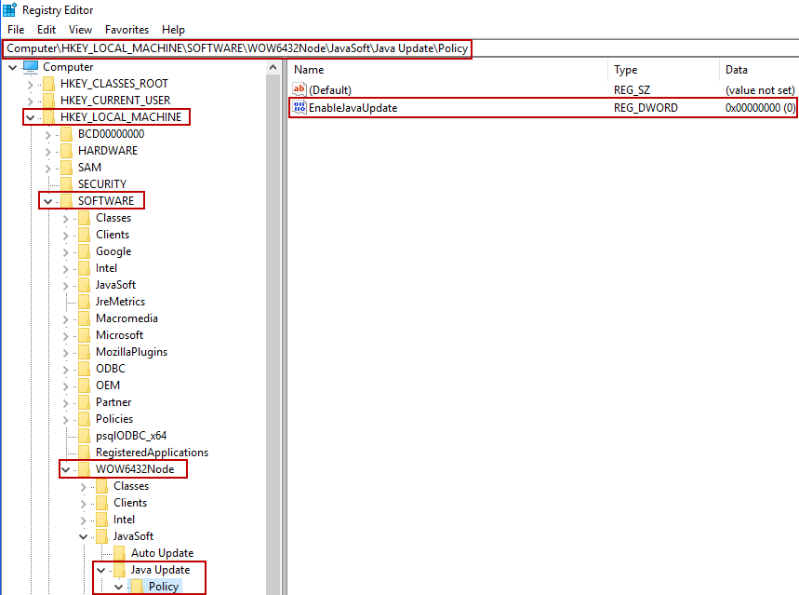
5. Close Registry Editor.

# Set Photo Viewer as default

By default, Windows 10 uses the new **Photos** app as the image viewer. To information about how to change this to Windows Photo Viewer, go to the following *How-To Geek* article:

<https://www.howtogeek.com/225844/how-to-make-windows-photo-viewer-your-default-image-viewer-on-windows-10/>

# Windows 10 Updates

To install the latest Windows 10 cumulative updates, search the Microsoft Software Catalog for the updates that are missing.

For example, if you are using build *1703*, search for the latest cumulative update to install for this build. To access the Microsoft Software Catalog, go to <https://www.catalog.update.microsoft.com/Search.aspx?q=1703%20cumulative>

# Cleanmgr.exe

Run **Disk Cleanup** before you capture the image. Disk Cleanup locates temporary files and unneeded windows updates. Delete these files to create more storage space.

1. Click **Start**, type *clean*, and then click **Disk Cleanup**.  
   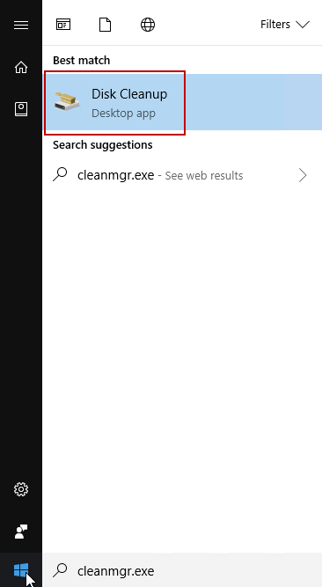
2. In the **Files to delete** area and click to select the check box beside the files to be deleted, and then click **OK**.   
   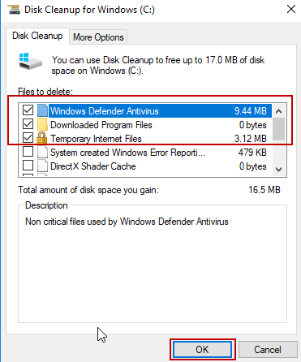
3. After the cleanup is finished, restart the VM.

# Capture the Image

1. Shutdown the VM computer.
2. Take a Snapshot of the VM. Make sure you put relevant into in the Snapshot name. You may also add information to the description field to highlight what changes this snapshot includes.
3. Start the VM.
4. On the desktop, double-click **Resume Task Sequence**. Thecapture process starts.
5. For information about where the captured .wim file is stored, see the SharePoint Build and Configure Knowledge Base article [Image Build and Capture using MDT Lite Touch - Windows 10.docx](https://rbauction.sharepoint.com/it/kb/build/Image%20Build%20and%20Capture%20using%20MDT%20Lite%20Touch%20-%20Windows%2010.docx).